Date | Initiated/updated | Revision History
05-12-2019 | Komal Shahid | Version 1.0

RESTORE DATABASE
- Click on MySQL Database(CPANEL)
- Create New Database

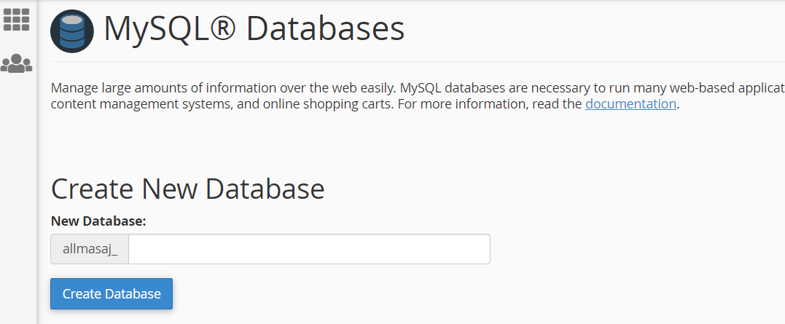
- Create User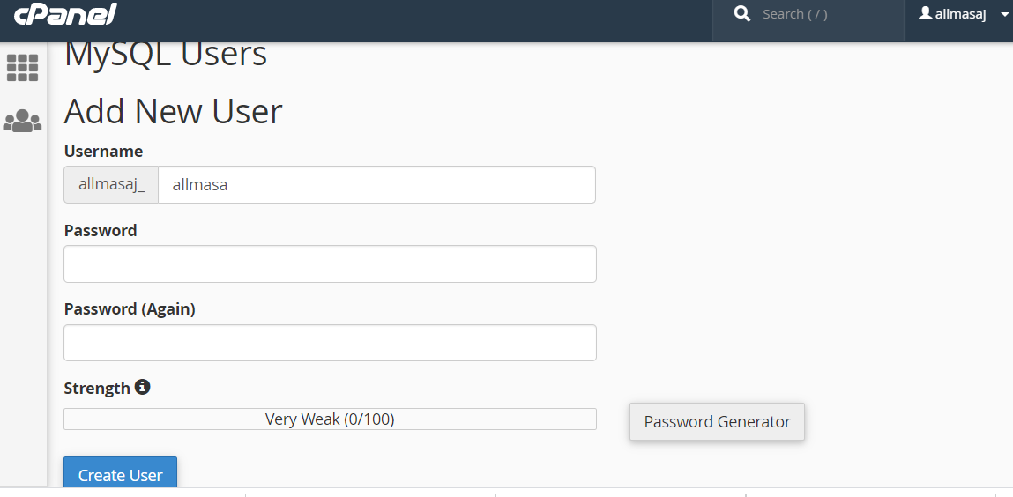

- Now add user to database
Now add all the database detail in the db configuration file in file manager folder.

