Built in functions in PHP 4
As we discussed functions in previous lectures, we will continue to discuss following functions in this lecture
- include () function
- require () function
- include_once () function
- require_once () function

include() function:
In PHP there is a function which is used to put contents of one file including the PHP code, into another file that is (include()) function. PHP provides a function which can takes the header, footer or some functions in one file and just show the contents by using the include function with the name of file. Include function takes all the text in specified file and use them where include function is used. This function will help the developers to change the layout of website by making different files of header, footer, body , sidebar and navbar. This function also reduces the developer’s effort to find the mistakes and made the changes in single file rather than in thousand of files. It copies all the text including source code, but if there is any problem to load that file then it will throw a warning but the execution don’t stop. For example if you want to make a file which includes only menu part then create a file with menu.php and type the following code.
Code:
<a href="#">Home</a> -
<a href="#">About us</a> -
<a href="#">Services</a> -
<a href="#">blog</a>
<a href="#">Contact us</a><br>
Then create file index.php and save the following code.
Code:
<!DOCTYPE html>
<html>
<head>
<title>Php include</title>
</head>
<body>
<?php include("menu.php"); ?>
<p>This is an example to show how to include PHP file!</p>

</body>
</html>
Output:
On your browser write localhost/project_name/index.php and it will show the following output.
Home - About us - Services - blog Contact us
This is an example to show how to include PHP file!
By using include function we can use one same file in thousands of file by just writing one piece of line, this function made the use of code easy and reusable. Here is the piece of above mentioned code.
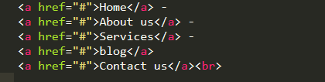
Figure 1

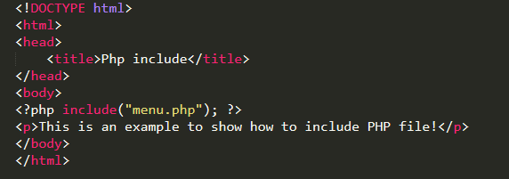
Figure 2

require () function:
require function is also used to put the contents of one file into another, it just like include function which takes all the text in a specified file and show the contents where function is used. But there is a difference between require function and include function that if file is missing or there is a problem in loading the file then require will throw a fatal error and halts the execution, whereas include function throw a warning error but the script continue to execute.
Code:
<a href="#">Home</a> -
<a href="#">About us</a> -
<a href="#">Services</a> -
<a href="#">blog</a>
<a href="#">Contact us</a><br>
Then create file index.php and save the following code.
Code:
<!DOCTYPE html>
<html>
<head>
<title>Php require</title>
</head>
<body>
<?php require("menu.php"); ?>
<p>This is an example to show how to use require in PHP file!</p>
</body>
</html>
Output:
On your browser type localhost/project_name/index.php and it will show the following output.
Home - About us - Services - blog Contact us
This is an example to show how to use require in PHP file!
Both outputs will be same, because both uses the same file and displays their contents. But if file is missing in both functions then they will behave differently.
Here is the illustration of the code.
Figure 3
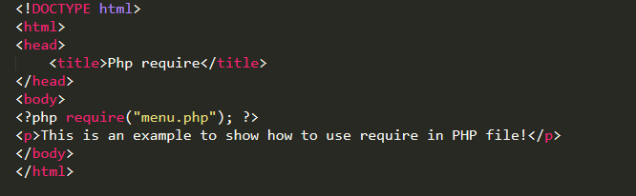
Figure 4
Let us take an example to see the difference when the file is missing in require function.
<!DOCTYPE html>
<html>
<head>
<title>Php require</title>
</head>
<body>
<?php require("men.php"); ?>
<p>This is an example to show how to use require PHP file!</p>
</body>
</html>
In the above example the file name is not correct, because the file name is menu.php and it will throw the fatal error and halts the execution of script that is in index.php.
Output
Warning: require(men.php): failed to open stream: No such file or directory in C:\xampp\htdocs\article\index.php on line 7
Fatal error: require(): Failed opening required 'men.php' (include_path='C:\xampp\php\PEAR') in C:\xampp\htdocs\article\index.php on line 7
Here is the snippet of the code.
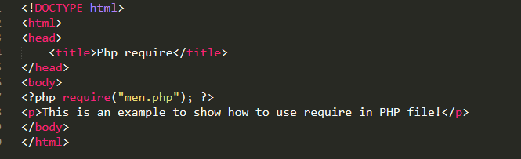
Figure 5
When file is missing in include function.
Code:
<!DOCTYPE html>
<html>
<head>
<title>Php include</title>
</head>
<body>
<?php include("men.php"); ?>
<p>This is an example to show how to include PHP file!</p>
</body>
</html>

Output
Warning: include(men.php): failed to open stream: No such file or directory in C:\xampp\htdocs\article\index.php on line 7
Warning: include(): Failed opening 'men.php' for inclusion (include_path='C:\xampp\php\PEAR') in C:\xampp\htdocs\article\index.php on line 7
This is an example to show how to include PHP file!
Above piece of code showing a warning that file is missing but continues with the execution of index.php which prints This is an example to show how to include PHP file!.
Here is the screenshot of the code.
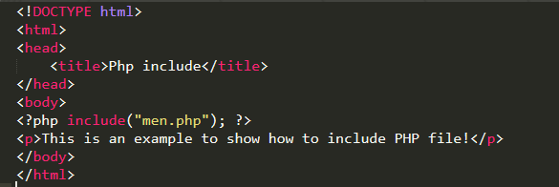
Figure 6

Include_once () function:
The (include_once) function is also used to show the contents of files as similar to include function but the main difference is that if the file is already included then it will not include the file again as the name suggests include_once. It will handle the inclusion of files that are included more than one time.
For example if there are thousands lines of code, and the file is included 2 times in the same file, then it will displays the same text twice, like this;
Code:
<!DOCTYPE html>
<html>
<head>
<title>Php include</title>
</head>
<body>
<?php include("menu.php"); ?>
<?php include("menu.php"); ?>
<p>This is an example to show how to include PHP file!</p>
</body>
</html>
Output:
Home - About us - Services - blog Contact us
Home - About us - Services - blog Contact us
This is an example to show how to include PHP file!
Here is the piece of code. 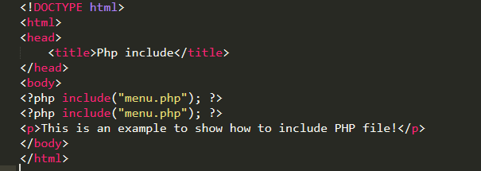
Figure 7
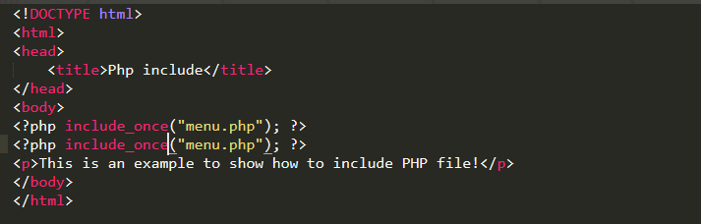
Figure 8
In figure 8 we use include_once two times but it results the output one time because it checks if the file is already present then ignore the second one.
Home - About us - Services - blog Contact us
This is an example to show how to include PHP file!

require_once () function:
The (require_once) function is also used to show the contents of files as similar to require function but the main difference is that it will check the file is already included before the execution then it will not include the file again as the name suggests require_once. It will take care of the inclusion of files that are included more than one time.

