Built in Functions in PHP 2
As we discussed functions in previous lectures, so in this lecture we will continue to discuss following functions.
- echo() Function
- strlen() Function
- strops () Function
- current() Function
- trim() Function
- strtolower() Function
- is_string() Function
- array_key() Function
- function_exists() Function
- date ()Function

echo()Function:
echo is also used to print or display the data, as it is relatable to (print_r) function. But the main difference between echo and print_r is that echo has no return value while print_r has a return value of 1 so it can be used in expressions.echo is used to print statements or strings.
Code:
<?php
$message="Hi I’m a string.";
echo $message;
?>
Echo can take more than one argument but in the case of print_r it can take only one argument. As it can be seen in our example ($message) variable contains a string in it, and echo is used to display the data stored in the ($message) variable.
Output
Hi I’m a string.
Here is the snippet of above code.

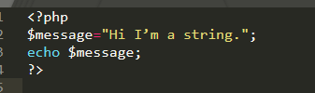
Figure 1

strlen()Function:
The strlen() function is used to return the length of a given string, it is PHP built-in function which is used to calculate the length of string including whitespaces and all the special characters. It takes variable as a parameter and checks the length and return a number.
Syntax:
strlen($variable);
Code:
<?php
$message="Hi I am a string.";
echo strlen($message);
?>
Output
16
From the example above you can count the words and spaces in the above code, it returns the output equal to 16.
Here is the illustration of the program.
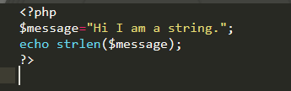
Figure 2

strops() Function
The strops() function is used to find the position of first occurrence of string inside another string. This means you can check the numeric position of a string.
Syntax:
strpos(string,find,start)
Code:
<?php
echo strpos("You can go an easy way !","easy");
?>
Output
14.
As strops() finds the numeric position of string in another string, so in the above example it finds the position of easy in the string, including the white spaces.
Here is the snapshot of the current program.
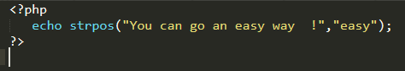
Figure 3

current () Function
The current () function is PHP built-in function:
- It is used to return the value of element in an array in which the current pointer is pointing too.
- On the returning the value, it does not return increment or decrement the pointer.
- In PHP every array has an internal pointer.
- The internal pointer points to some element in the array which is the current pointer.
- Usually, the current pointer is the first inserted element in the array.
Syntax:
current($array);
Code:
<?php
$colors =array('red','green','blue','orange');
echo current($colors);
?>
Output
red
It returns the current pointing element in the array.
Here is the screenshot of the code.
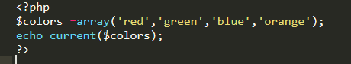
Figure 4

trim () Function
The trim() function is used to remove the white spaces and other predefined characters from the left and right sides of a string.
Syntax:
trim(string_name,char_list);
char_list specifies the characters to be removed. When char list is not used in the function, then only white spaces are removed.

Code:
<?php
$str = "Hello World!";
echo trim($str,"H");
?>
Output
ello World!
In above code, character (H) would be removed because of trim function.
Figure 5 illustrates the program.
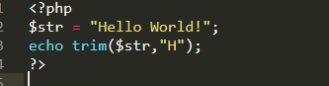
Figure 5

strtolower() Function
The strtolower function coverts the string into lower case.This function takes the string as parameter and converts all the upper-case English alphabets into lower-case English alphabets. All other numeric character and special character remains unchanged.
Syntax:
strtolower($string)
Code:
<?php
$str = "THIS IS A PROGRAM OF STRTOLOWER FUNCTION";
echo strtolower($str);
?>
Output
this is a program of strtolower function
In the above program, PHP function (strtolower) changes the upper-case letters into lower case letter.
Here is the pictorial illustration in Figure 6.
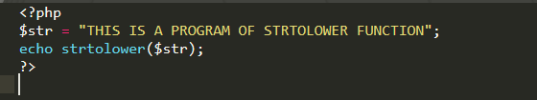
Figure 6

is_string() Function
The (is_string) function is used to check whether the variable is string or not. A string is a data type such as floating point or integers.A string uses a set of characters that includes spaces and numbers.is_stringfunction is used with if condition that whether variable is a string or not.
Syntax:
is_string($string)
Code:
<?php
$str = "Hi my name is Olivia";
if(is_string($str)){
echo "Yes";
}
else{
echo "no";
}
?>
Output
Yes
The output is“Yes” because ($str) is a string and then if condition gets true and “if” part of code executes .
If variable is not string then it will execute the else part, for example:
Screenshot of the above code:
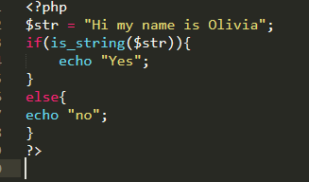
Figure 7
Code:
<?php
$str = array('1');
if(is_string($str)){
echo "Yes";
}
else{
echo "No";
}
?>

Output
No
In this situation as the ($str) variable is an array and if condition gets false then else part will be executed.
Here is the code snippet.
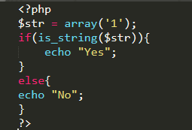
Figure 8

array_key() Function
The array_key function is used to get all the keys in the array. It is commonly used in associative arrays to check the index of the key.
Syntax:
array_keys($array);
Code:
<?php
$array=array("Nick"=>10, "Mark"=>20, "John"=>100 ,"Robert"=>500);
print_r(array_keys($array));
?>
Output
Array ( [0] => Nick [1] => Mark [2] => John [3] => Robert )
Figure 9 represents the code.
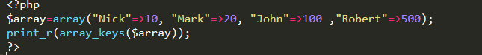
Figure 9

function_exists() Function
The (function_exists) is a built-in function which is used to check that whether the function exists or not. It can check the existence of a user defined function or PHP built-in function. This function returns the boolean value, it may be true or false, and uses if condition to check whether the provided function exist in script or not.
Code:
<?php
if(function_exists('in_array')){
echo "Found";
}else{
echo "Not found";
}
?>
Output
Found
Above piece of code can be used to check the existence of built-in functions or user defined functions that whether the function exist or not.
Here is the piece of code in Figure 10.

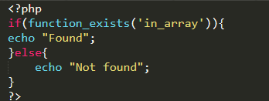
Figure 10

date() Function
PHP date function is used to format the date and time in the human readable format.
Syntax:
date(format).
In date function, default format is (Y-m-d).
- (Y-m-d) is the PHP format for YYY-MM-DD.
- Y stands for year, a four digit representation for year.
- m stands for month(from 01 to 12)
- d stands for day(from 01 to 31)
Code:
<?php
$date=date('Y-m-d');
echo $date;
?>
Output
2019-10-12
It returns the current date.
Figure 11 shows the snippet of the above-mentioned code:

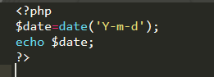
Figure 11

