Built in functions in PHP
In our previous lectures, we discussed about functions as functions are the self-contained piece of block and PHP contains thousands of built in functions that are made to reduce the effort of human being. They are ready to use by just calling their names.
As PHP contains thousand s of function, we will discuss only which are commonly used.

PHP | count() Function
The count function returns the number of element in an array. Count function is used to check number the number of elements in array. For example if you want to check the size of the data stored, you should use count function as it sum up the total number of elements. Use of count function is as below:
Code:
<?php
$names;// initializing variable
$names =array(0,1,2,3,4,5,6);
echo count($names);
?>
Output:
7
($name) variable is initialized and declared as an array. Count returns the total number of values present in the ($name) array that is 7.Here is the illustration of the code block.
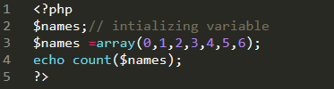
Figure 1

PHP | isset() Function
Isset is a built-in function which is used to check whether the variable is set and is not null. isset function is generally used to get $_POST array data. $_POST is used to get the values which are coming from the form whose method is post. ISSET function is used to check if the form is submitted or not. Take an example to understand it clearly. First create two files form.php and procees.php in your htdocs folder of xampp.Now in form.php write the following code.
Code:
<!DOCTYPE html>
<html>
<head>
<title>MY FIRST FORM </title>
</head>
<body>
<form method="post" action=" process.php">
<label> type your name:</label>
<input type="text" name="text_name">
<input type="submit" name="submit">
</form>

</body>
</html>
Save the below code in process.php.
<?php
//now we will get the form data by using $_POST array
if(isset($_POST['submit'])){

$name=$_POST['text_name'];

print 'hello' .$name; } ?>
In form.php html form is used, method is post and action means where the data goes. When the user click on input type submit button, then in process.php “isset” functions checks that the $_POST array contains ‘submit’ then the following lines of code would execute otherwise don’t execute the code block. In the code block $name is a variable which sets its value to the $_POST array data containing the key with name of (name),then print the name which is coming from the user form.
Snapshot of the code:
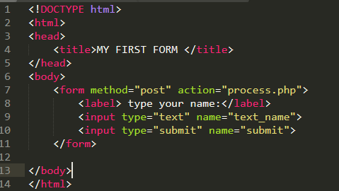
Figure 2
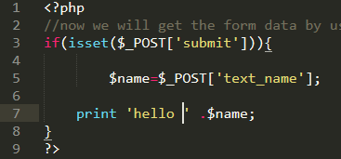
Figure 3

PHP | is_array () Function
is_array function is used to find whether the variable is an array or not. The following example clarify how to use is_array function
Syntax:
is_array($variable_name);
Code:
<?php
$names;// initializing variable
$names =array(0,1,2,3,4,5,6);
if(is_array($names)){
echo "This is an array";
}else{
echo "This is not an array.";
}
?>
In above program,($name)variable is initialized, and declared as an array, now if condition is used to check whether the coming variable is an array or not, so (is_array) function is used to check ($name) variable. If (if) condition gets true, it will print the statement that(this is an array) otherwise else condition will execute.
Result of this program:
This is an array
Illustration can be seen in Figure No 4.
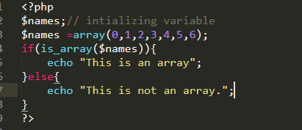
Figure 4

PHP | in_array () Function
in_array function is used to check whether the value is in array or not. It is useful to check some specific value in the array.
Code
<?php
$names;// initializing variable
$names =array(0,1,2,3,4,5,6);
if(in_array("0",$names)){
echo 'Found';
}else{
echo "Not found.";
}
?>
In these lines of code,($name )variable is initialized, and declared as an array and if condition is used to check that (0) value is present or not.(If) condition gets true it will execute the block of code, otherwise else part is executed

Output.
Found

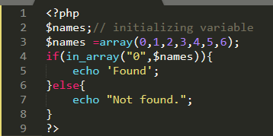
Figure 5

PHP | array_key_exixts () Function
array_key_exists function is used to check whether the key is present or not.
Code:
<?php
$names;// intializing variable
$names = array("Emma"=> 60, "Olivia"=> 50, "Isabella"=> 30, );
if(array_key_exists('Emma', $names)){
echo 'Found';} else{ echo "Not found.";} ?>

Output.
Found

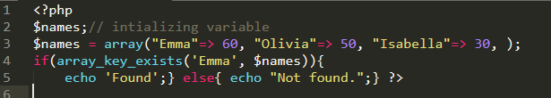
Figure 6

PHP | array_merge() Function
array_merge is used to combine arrays. it returns an array in which elements of all the arrays comes which is passed in the array_merge parameter.

Code:
<?php
$array1 =array('red','green');
$array2=array('blue','white');
$colors=(array_merge($array1,$array2));
print_r($colors);die;
?>

Output:
Array ( [0] => red [1] => green [2] => blue [3] => white )
It returns both the values in the array by merging both arrays in single one.

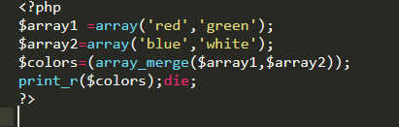
Figure 7

PHP | explode () Function
The explode function is used to "Split a string by a specified string into pieces i.e. it breaks a string into an array". The explode functions allows us to break the string into smaller pieces. Using explode function we can convert a string into array.

Syntax:
explode (separator, string, limit)
For example you have a string of string of (A, E, I, O, U) now you want to separate the letters by assigning them into a string so that you can fetch them by their keys.

Code:
<?php
$str="A E I O U"; // string
$arr = explode(" ", $str);// using explode function
print_r($arr);
?>
By using explode function in the above program, the ($str) variable contains a string and then the ($str) variable is passed in explode function which results the string to convert into string.

Output:
Array ( [0] => A [1] => E [2] => I [3] => O [4] => U )

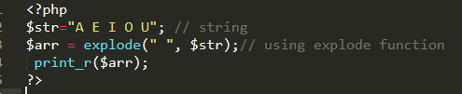
Figure 8

PHP | print_r () Function
The print_r() function is used to print or display the information stored in a variable.

Syntax:
print_r($variable);
($variable) specifies that this variable has to be printed.

Code:
<?php
$str="Hi this is a string"; // string
print_r($str);
?>
($str) contains the sting in it, and (print_r) is used to display the data stored in the variable ($str).

Output:
Hi this is a string

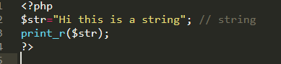
Figure 9

PHP | implode () Function
The implode function is used to covert an array to string, it work like a glue. The implode() function returns a string from elements of an array. It takes an array of strings and joins them together into one string using a delimiter (string to be used between the pieces) of your choice. The implode function is easily remember by array to string.

Code:
<?php
$arr=array ('this','is','an','array!');
echo implode(" ",$arr);
?>

Output:
this is an array!
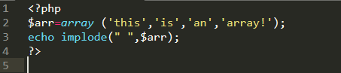
Figure 10

