Date | Initiated/updated | Revision History
04-02-2020 | Komal Shahid | Version 1.0

Ads Management system:
Revive Adserver :
Revive Adserver is a free, open source ad server. It is a system that can be used to manage and optimize the advertising space on one or more websites.
Installation Guide:
- Download revive software from the following link. https://www.revive-adserver.com/download/
- Install on local Server:
- Extract the folder into the following directory C:\xampp\htdocs.
- Create a database in your mysql database.
- Open the localhost path in browser and hit the folder name by which it is saved the htdocs directory.
- Follow the screen instructions to deploy the software.
- Install on web Server:
- Extract the folder into the public html
- Create a database in your PHP M admin database.
- Open the domain path in browser and hit the folder name by which it is saved the public html directory.
- Follow the screen instructions to deploy the software.
User Guide:
- Create advertiser.
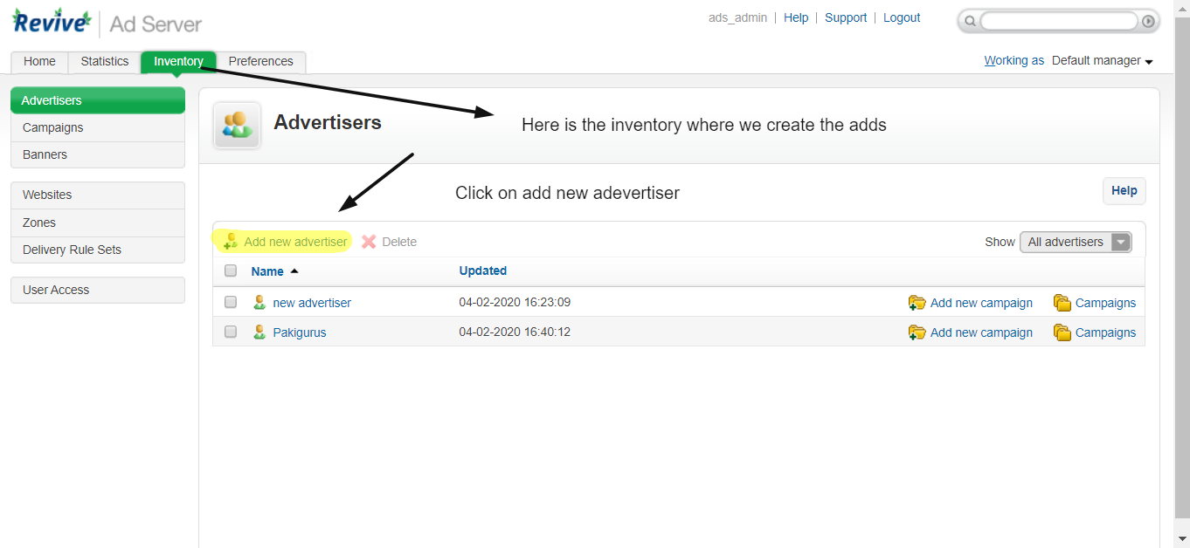

- The following screen appear fill the required details.
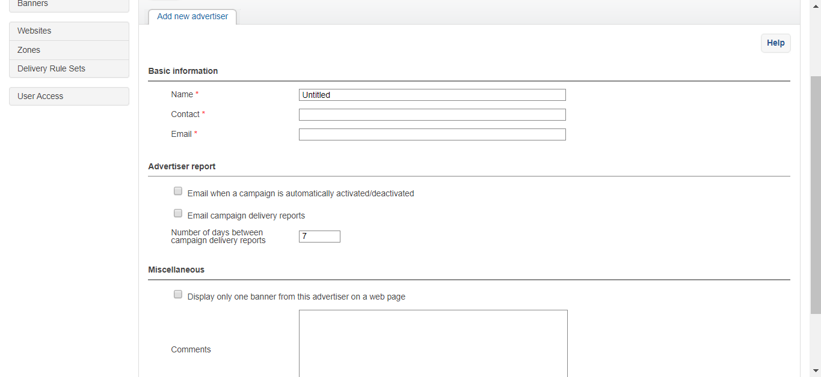
- Create a new campaign against advertiser.
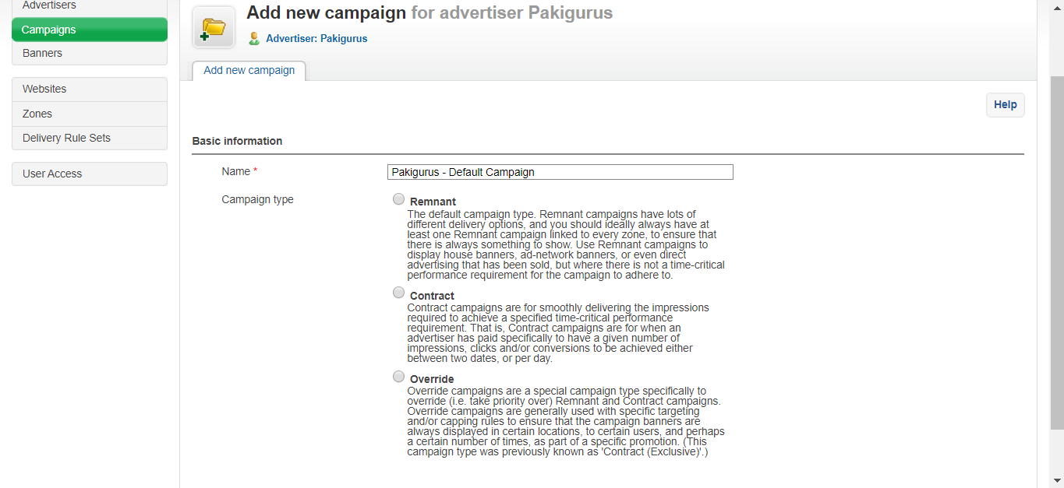

- Create an ad banner against the campaign.
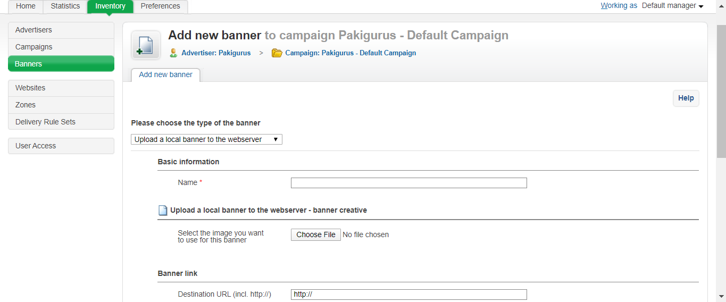

- Now create a website.
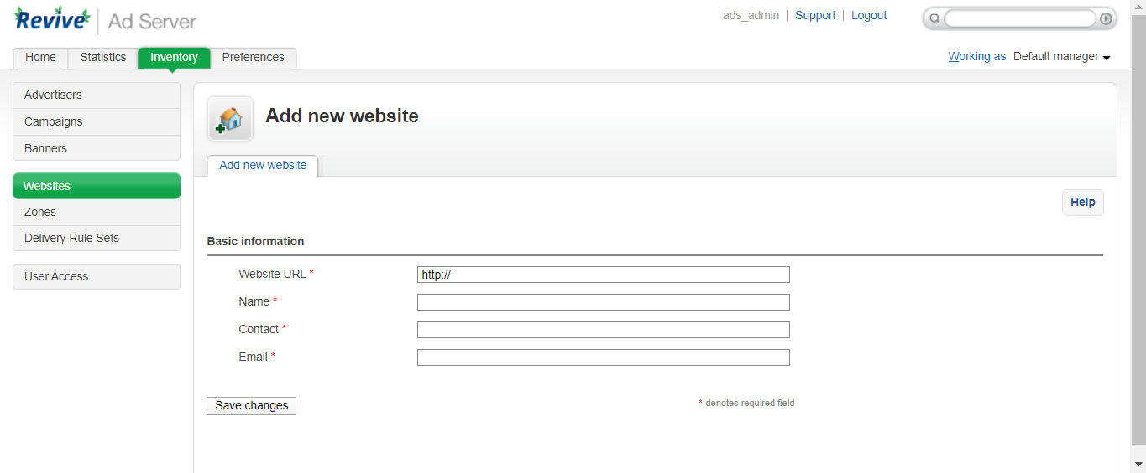

- Now create zone against the website.
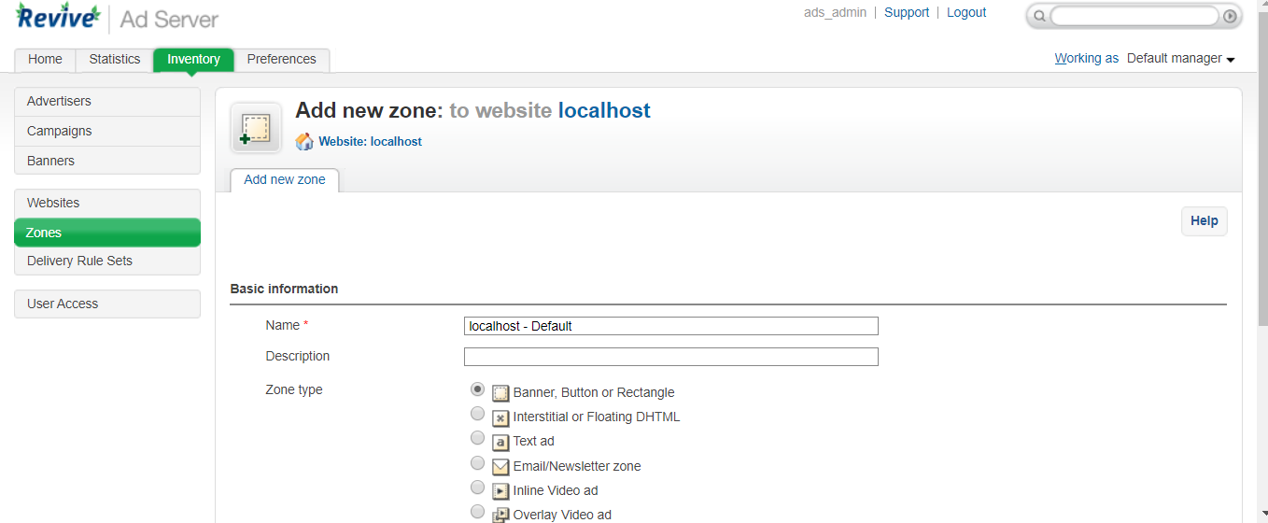

Note*
The zone image and banner image size/dimensions should be the same.
- Now after creating zones, go back to zones and click on link banners.
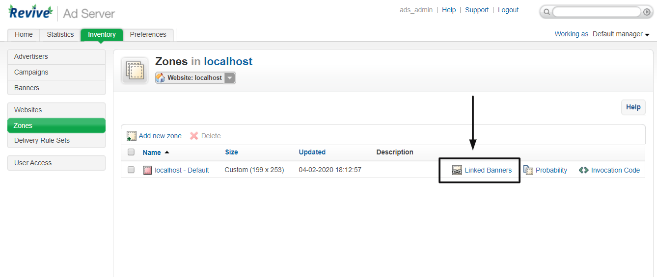

- Now select advertiser from the dropdown and then after selecting the advertiser select campaign.
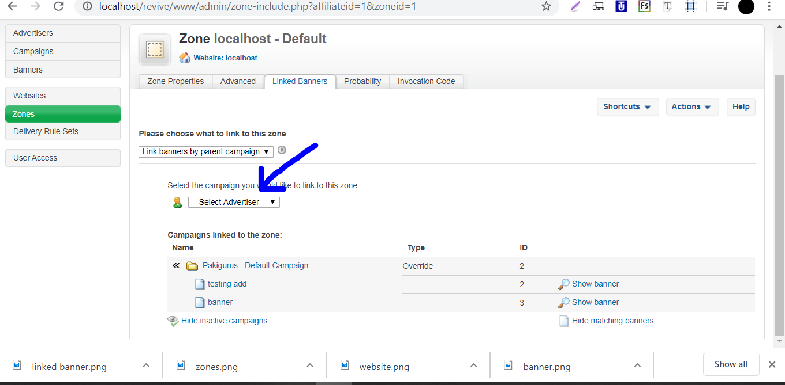

- Now click on show banner that how it shows on website.
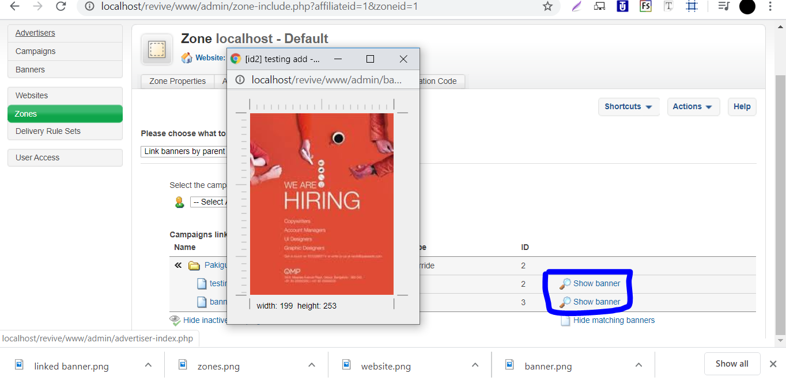

- Now go back to zones and click on invocation code.
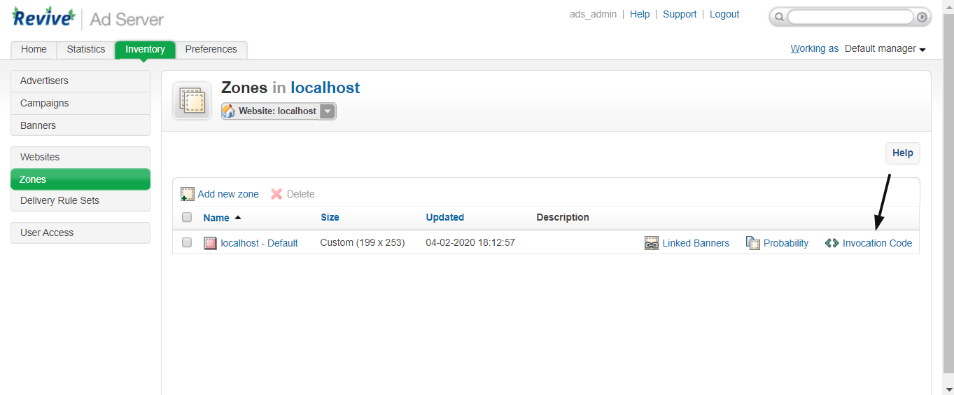

- Now copy the script from the following and place in your website.
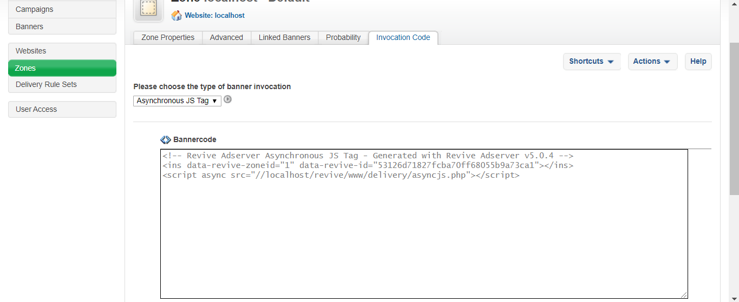

Permissions/User Access
In this software we can also create users which has defined access.
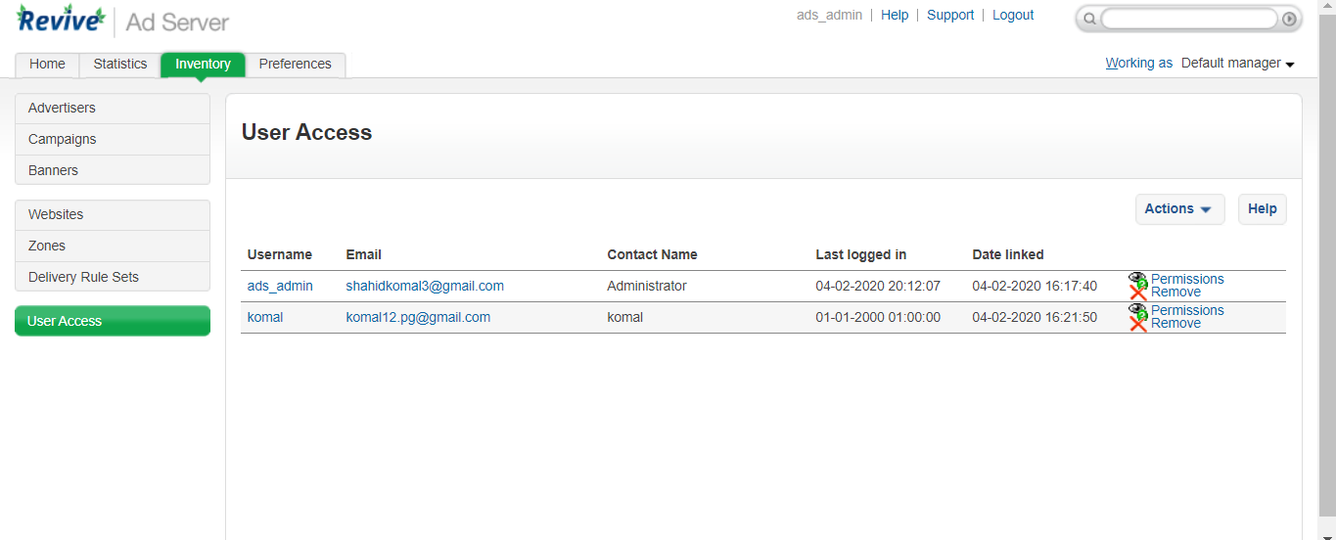
Here are the user access properties.
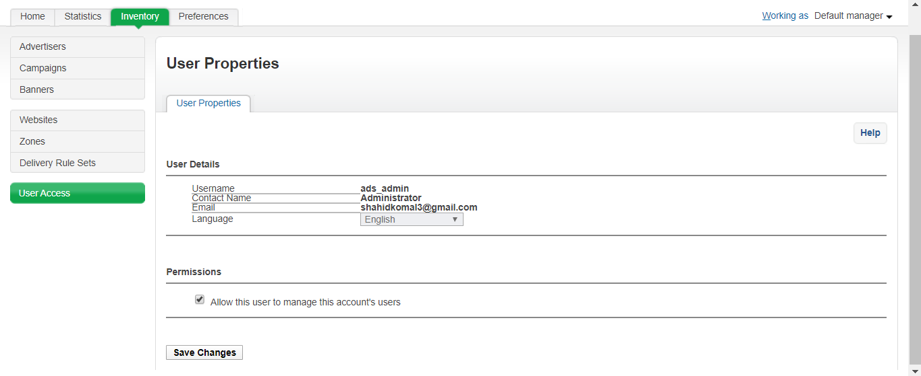
Dashboard:
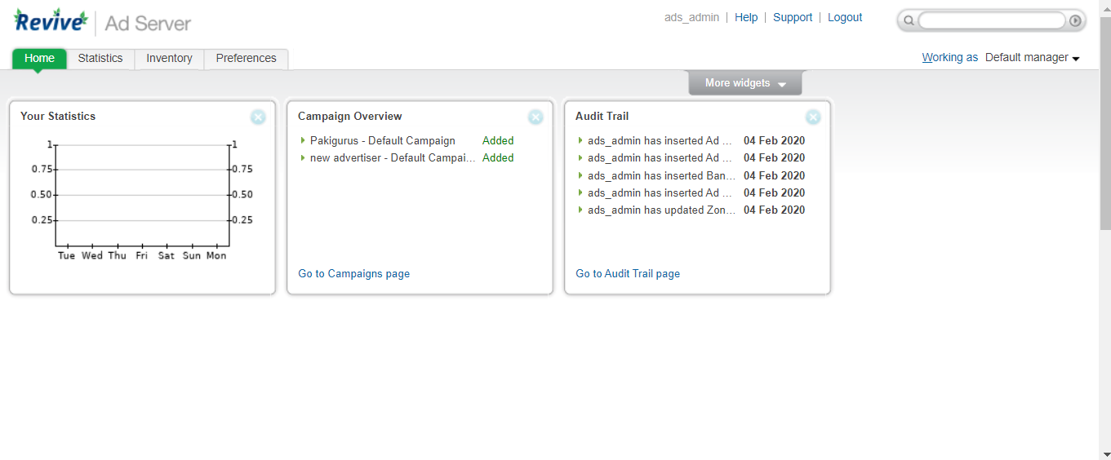

Statistics against campaigns:
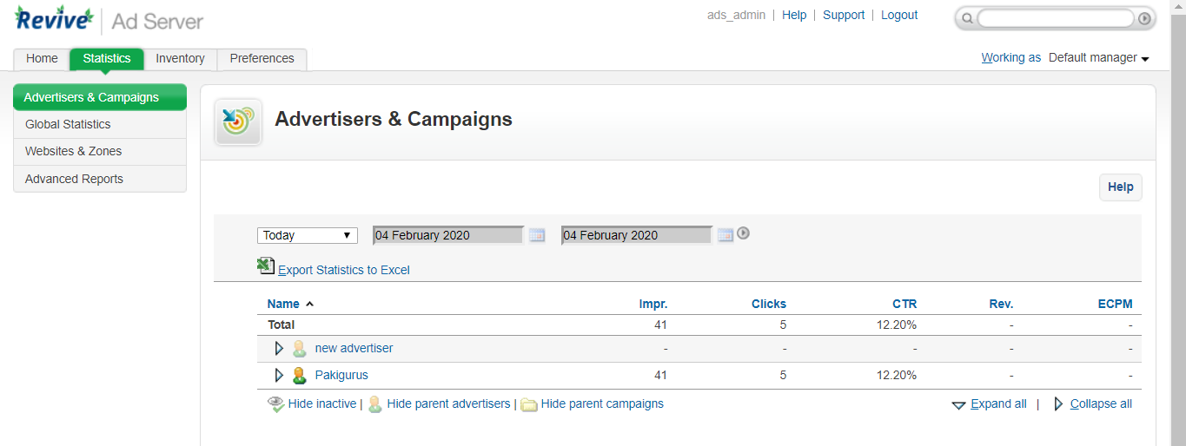

It’s an open source ads management software, in which we create different campaigns against different advertiser, it also gives the statistics report of our adds click, by this we can manage the advertisers. We have to make adds and place on our websites it’s a best and open source product else we the product like this took above 2 months to develop.

